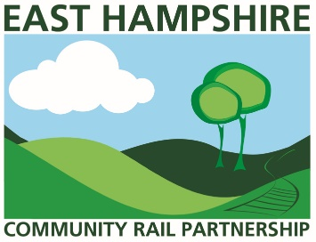
Dreaming of taking the train competition
Entry form
Name:
Age:
Email address:
Phone number:
Terms and Conditions
- This competition is free to enter
- All competition entries must have been produced or created by the person submitting the entry, i.e. it must be their own work, not produced under tuition and must be completed within this competition period.
- The organisers will not be held responsible for any copyright infringement by entrants and reserve the right to exclude any item that is considered inappropriate or to breach any of the entry conditions
- Deadline: 1200, Friday 1 May 2020
- All entries must be submitted via e mail to info@easthampshirerail.co.uk
- The judges’ decisions will be final. (Judges will be representatives of East Hampshire Community Rail Partnership, South Western Railways and Petersfield Community Radio.)
Please note your details will be used to communicate with you regarding Dreaming of taking the train competition. The East Hampshire Community Rail Partnership will not share your data with any third party.
Please sign below to indicate that you agree the data, provided on this form, may be stored only for the purpose mentioned above and that we may take collective photographs, which may include my entry for use in marketing materials to promote the competition. This may include social media and promotion of the competition.
If you would like to receive regular information from the East Hampshire Community Rail Partnership about our activities in the future please tick the box

You may opt out at any time by emailing info@easthampshirerail.co.uk
Signature (Parent or guardian signature required if entrant is 16 or under)
Signature………………………………………………………….. Date……………..………………
www.easthampshirerail.co.uk

