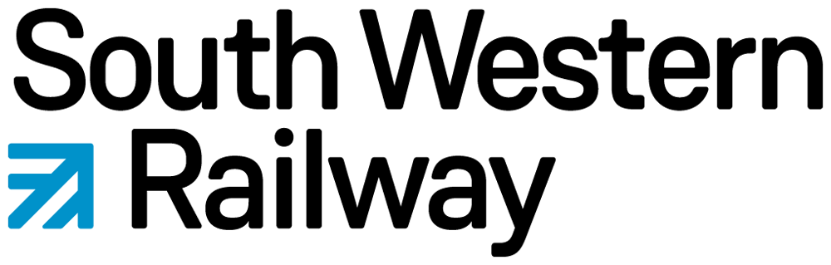
Form 1SWR

APPLICATION TO SOUTH WESTERN RAILWAY’S STATION ADOPTION FUND
Administered by Community Rail Network
(Please read the Application Guidelines first)

Name of adopters / friends / community station organisation:

Name of contact person:

Contact details (email will suffice):

Project name:

Project Details:

What is the main benefit of this project?

Have you got written permission and clearance from South Western Railway and Network Rail (if applicable) to undertake this work? Yes [ ] or Not Applicable[ ]. If yes, please provide evidence.

Total cost of project: Amount requested from SWR: % of total cost of project:

What products/services will the money requested from the SWR Station Adoption Fund will be used for?

Please include any supporting information which may be relevant, such as quotes from suppliers:

Enter your name here to confirm you are happy with everything on this form: Date:
Form 1SWR
SWR STATION ADOPTION FUND: GUIDELINES FOR APPLICANTS

SWR funding enables member organisations to undertake small projects that aim to benefit the station they have adopted.

The following criteria apply:

- The fund can only provide grants to organisations that have station adoption or community station membership of Community Rail Network through the SWR programme.
- Applications can only be accepted if made on Form 1SWR.
- The fund can support projects up to a maximum contribution of £250, or up to £1000 for groups with Community Rail Network community station membership.
- Applications from station friends/adopters in excess of £250 may be supported but only with the prior involvement and agreement in writing of SWR’s Community Rail Manager
- The fund does not support projects that are already underway or completed, unless agreed by SWR’s Community Rail Manager in writing.
- Applications will be considered at any time and may be determined by agreement of the Community Rail Network Chair, Deputy Chief Executive and Head of Support and Development, Community rail Support Manager and SWR representatives.
- SWR support should be clearly acknowledged in press releases and other publicity, and, where appropriate, typically through use of the SWR logo which is included in the email notifying an applicant of approved funding.
- While more than one application per year is acceptable, in considering bids there will be a presumption in favour of applicants who have not made a successful application earlier in the same year. However, this is subject to available funds, and a good application from a previously successful applicant would not necessarily be rejected.
- Grants will remain claimable for up to three months following the award date. Grants remaining unclaimed after this date will be cancelled and the funds made available to other applicants.
- The level of grant awarded is at the partners’ discretion who reserve the right to part-fund or refuse a bid as they see fit.
- The completed form must be emailed to grants@communityrail.org.uk who will acknowledge receipt and give an indication as to when we expect the application to be considered by. This will normally be within 14 days.

What sort of projects are eligible?

The fund exists to assist members in developing a wide range of practical schemes which make a real difference to the stations they have adopted and should not generally be used to support projects that more properly should be provided by the rail industry or other agencies.

Data Privacy: Personal information supplied on this form will be used to communicate with you specifically about your grant application, and to allow us to evaluate and assess the progress of the project for which you are applying for funds. It will not be used for any other purpose. This information will be processed, stored & transported lawfully and correctly, in accordance with the principles and safeguards contained in the Data Protection Act 1998, GDPR Regulations (Article 5) and Data Protection Act 2018. Your personal information may be shared with third parties, such as the Department for Transport, Network Rail, train operating companies and devolved government, where it is deemed necessary to assess the application. Community Rail Network’s Data Privacy Policy can be found on its website.

Rev 23/09/21

