Activity Reports on Impact
Impact users with Reporter status will be able to see a Reports tab on the top menu and access Activity reports via the Activities tab. If you are an Impact user and you do not have access to the Reports function and you would like to generate reports on your activities and download them into Excel/csv files contact impact@communityrail.org.uk

What an activity report can show
- What an individual has recorded for this activity
- What everyone in the team (your organisation) has recorded for this activity
- The data that has been recorded for each of the logs
- What extra notes have been added in the description box
- How the activity has been classified e.g. community rail strategy pillar or target audience
How to generate an activity report
Go to the Activity tab and click on an activity. This takes you to the activity summary page (see below).
You will see a chart showing you what has been recorded so far with the tabs on the chart showing the different sets of data.
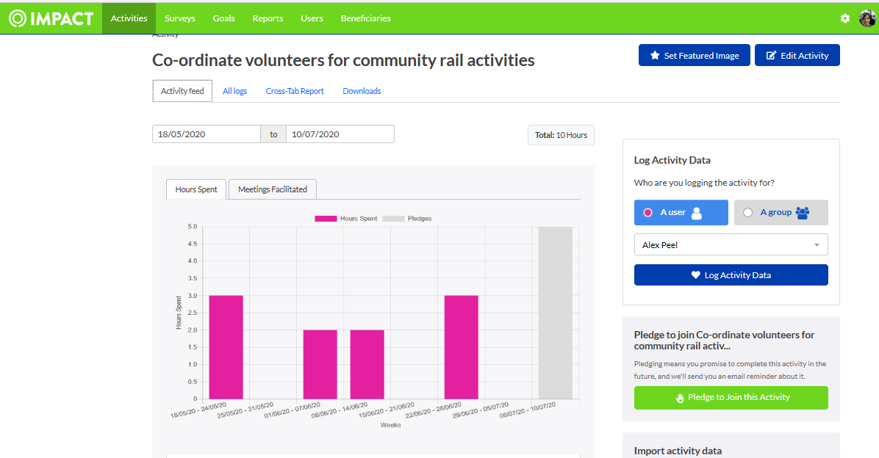

To download the information into an Excel/csv file click the Downloads tab above the chart on the summary page and this will allow you to refine the options for your report (see below)
Choose the dates for the report and which logs you want to see
In the Aggregate by section press None
Then click Generate Report

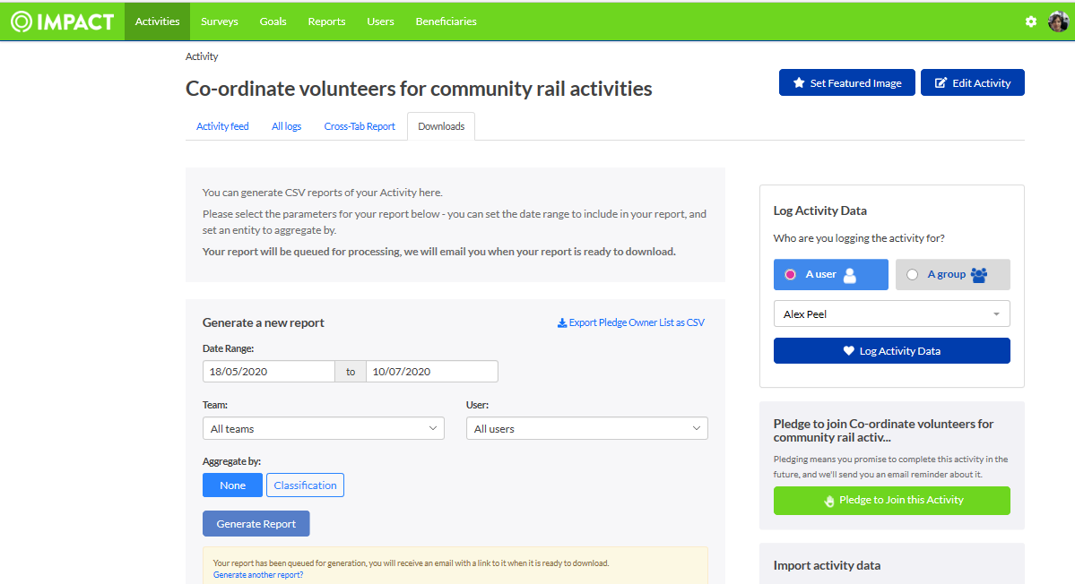
A notification will pop up on your profile picture in the top right and you will also get an email. You can then click to download the report.
Here is an image of the report generated.
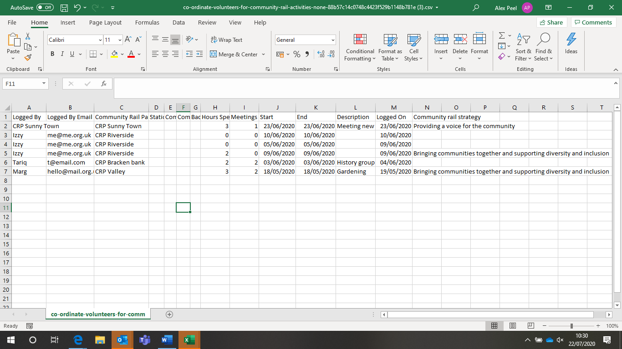
Report Columns
A: Who has logged – if the user has logged under their own name it will show that otherwise it will show the name of the group they logged on behalf of
B: Email address of user
C-G: These columns show the CRN membership and group categories on Impact and which category the log belongs to e.g. CRP, Community Station, Station Friends group. You can easily delete the columns that are not relevant to your group
H: Data recorded against a recording category e.g. Hours
I: Data recorded against a recording category e.g. Number of meetings
J: Start date of log
K: End date of log
L: Description – includes text entered into the description box. Your group could agree codes to use at the beginning of any text descriptions to help sort your logs
M: Date log was made
N: Classification – shows the choice made against a classification. This is not relevant for all activities. In this case some users have chosen a pillar of the community rail strategy. Other classifications on different activities include target audience, lines (for CRPs working across multiple lines) and marketing/communications methods.
If you want to see the total values logged against classifications then click Aggregate by and Classification. The downloaded spreadsheet will give a list of all available classifications for that activity with the total values for the report parameters you have chosen (date range, users etc).

The Reports tab gives you access to a greater range of filters and enables you to pull off information across activities e.g. all activities for a user or an organisation. However, if you need the descriptive text for an activity you will only get this from the Activity Reports illustrated above.

Contact impact@communityrail.org.uk if you have any questions about reports or if you would like to tailor activity logs to ensure you can collect the information you need.

