Community Rail News – Guidance for submitting news stories
Community Rail News is our fortnightly email bulletin that highlights initiatives and projects and showcases examples of best practice from across community rail.
Our subscribers include community rail officers and volunteers, rail industry, government and third sector partners, as well as those with a general interest in keeping up to date with our work and our members’ activities.
We are always keen to hear your good news stories and help to amplify them. If you have press releases, articles or news-worthy stories relating to projects or events run by your organisation, we want to feature them in Community Rail News and on our website.
In order for us to effectively share your stories with our subscribers, it is important that the submissions we receive are as detailed and comprehensive as possible. We thought it would be helpful to provide some pointers on how to create a strong story for Community Rail News.
All completed bulletin submissions, along with relevant photographs (see more info below), can be sent to news@communityrail.org.uk for inclusion in the next Community Rail News.
As always, if you need any support with your submission or any aspect of your organisation’s communications and marketing, please contact our Communications and Marketing Officer Erin on erin@communityrail.org.uk.
We are also always keen to hear about news stories and events from our Partners. If you have a story or event that you would like to share with us, please send your press releases/articles to news@communityrail.org.uk. If you need any advice on the information that we’re looking for to include in our newsletter, please see below.

***

What makes a good news story?
Examples of strong story themes could include:
- The launch or completion of a community rail project, activity, or event
- Specific events based in and around the railway and stations
- Promotional campaigns geared towards getting more people using trains
- Work involving young people, schools, or some form of marginalised group
- Award wins or any outstanding achievements by particular group members
Please find below all the information our team find it helpful to have in order to feature your story. You will also find an example of a strong news story at the end of this guidance.

Constructing your news story
When putting together a submission for Community Rail News, it is useful to think about the 5 W’s of writing.
For your story to interest and engage readers, we need to know:
Who
- Who was involved? Which community rail groups, partner organisations, funders, members of the community, etc.
What
- What happened? How did you undertake the project / event / campaign / activity? How did it come about? What was involved at each of the different stages? What was the end result?
When
- When did each stage of the events occur?
Where
- Which area of the country are you based in? Where did events take place?
Why
- Why did you undertake the project / event / campaign / activity? Why is it important to your community rail group and your wider community?

If you are able to cover each of these sections, you will have produced a thorough and detailed story submission that, after just a small amount of editing, will be ready for publication in Community Rail News. Remember, you are writing a summary of your events to celebrate, inspire, and educate.

Quotes and Images
The strongest stories are accompanied by quotes and images.
Quotes allow you to inject some colour and emotion into your piece. The quote will usually be an opinion or reaction, and as such you should avoid quoting factual information.
Where possible, you should include at least one high-quality image with every news story you submit. If the story is linked to a particular project, event or campaign, provide pictures that allow people to make an obvious connection between the story and the image.
Make sure that the people in your photo(s) are willing and happy participants and have consented to their photo being taken and shared. If you are taking photos of children, you must get the necessary permission from either parents or schoolteachers to allow the image to be used. When sending in your story submission to us here at Community Rail Network, state on either the story / press release or the email that you have obtained consent for any photo(s) attached to be used on our website and in our newsletter. If you need any guidance around consent, then please do get in touch and we can provide a form that you can use.
If the person who took the photo consents to their photo being used but wishes to be credited, make sure to also include this information in your submission.

Checklist for a strong news story
Before sending us your story, please where possible make sure that it includes:
- Information relating to the 5 W’s
- A website link for more information – this could be to your own website or social media page
- At least one quote
- At least one photograph
As part of the process of preparing our bulletin, the Comms team at Community Rail Network may edit submissions to ensure clarity. Erin or another member of the team will always ensure to speak to you directly if significant edits need to be made, or further information is required.
If you would like further advice and support on creating a strong news story or on other communications, please get in touch with Erin via erin@communityrail.org.uk.

Example
The following is an example of a strong news story. You can see further examples of previous stories we have published here.

Friends of Buxton Station turn trashed poppies into recycled tributes
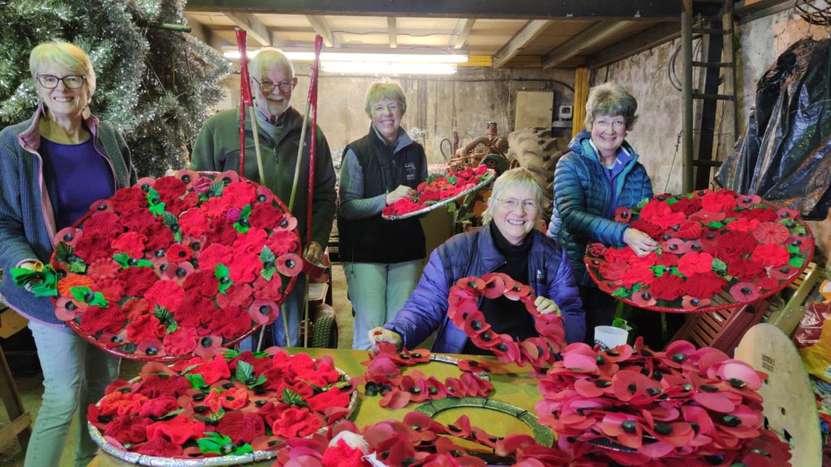The Buxton Baublers putting the finishing touches to their artwork.

The Friends of Buxton Station (FoBS) have saved around 1,500 old poppy wreaths from heading to landfill by repurposing them for a special art project tribute.
When FoBS first came across the old wreaths, they asked High Peak Borough Council if they could do something with them. The Council were more than happy to help and work with the group, as the poppies used in the wreath construction could not be recycled like the pin-type paper poppies, as they were made out of a different material.
Aware of the possible upset to people who had donated the Remembrance wreaths, the volunteers agreed that they would only be used in a respectful art project, complementing the poppies’ original purpose. FoBS asked around and found willing partners in Buxton Town Team, who have a group of fellow volunteers, The Baublers, specialising in adorning the town with homemade Christmas decorations.
Around 1,500 poppies were taken in by FoBS, who separated them from the damaged plastic wreath bodies. The poppies were handed over to The Baublers, who stitched, glued and strung them together to form a special tribute to The Poppy Factory, as it celebrated its centenary.
The Poppy Factory is a charity that was created in 1922 to employ wounded Soldiers returning from the First World War. They make remembrance wreaths for the Royal British Legion that are sold to support the annual Poppy Appeal, which in turn supports members of the armed forces in need.
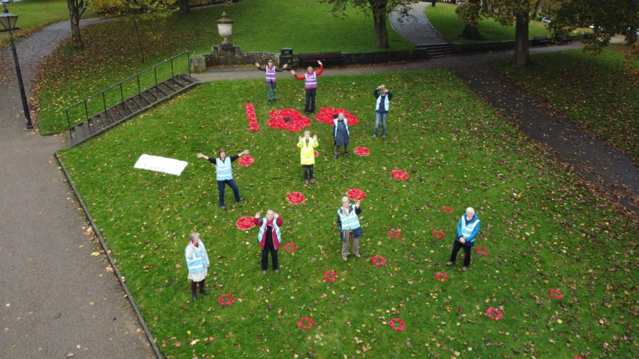The ‘Poppy Factory at 100’ installation. Photo credit: Mike Dawson.
Dave Carlisle, Chairman of FoBS, said: “We didn’t like the idea that these tributes to those who died in conflict were simply chucked away. We asked lots of questions and found out that they were different from the paper poppies that can be recycled.
“We have petitioned the Royal British Legion about this, and they tell us that they are working towards all poppies being recyclable. Our collaborative project has made something wonderful out of something destined for the tip.”
Tina Heathcote, one of the Baublers’ Coordinators, said: “Special mention goes to all the people who have knitted poppies to go alongside the silky recycled ones as Buxton’s contribution to remembrance. A lot of people have proudly dedicated time to make this tribute very special and memorable.”
Dan Hodges, The Poppy Factory’s Senior Communications Manager, said: “Thank you Buxton for your support for The Poppy Factory in our centenary year. It’s great to know that our work as a charity has such support.”
The resultant display features centrally on The Slopes, near to the War Memorial in Buxton.
Keep up to date with the projects and events from FoBS via their Facebook page.

Conclusion
We hope you found this guidance sheet useful when preparing your stories for Community Rail News. Remember, the Comms team is always here to support you and we are keen to promote the wonderful work you all do. Please do get in touch if you need support with any PR, media or social media work.
Many thanks and best wishes,
The Communications and Policy Team, Community Rail Network
news@communityrail.org.uk
January 2023

