Impact surveys
The survey function is available to Impact users and falls under the terms of the existing user agreement that you have signed.
Your survey will be visible to Community Rail Network staff but not to other members as long as you follow the visibility guidelines below. Community Rail Network staff will not share the results of your survey unless you specifically ask us to do so.
Things to note before you start
Some users will be able to create their own surveys direct from the Surveys tab on the top blue menu by clicking the green ‘add new surveys’ button in the top right-hand corner. Other users will need to request a blank survey from the Impact admin team by emailing impact@communityrail.org.uk – this will then appear on your surveys page and you can change the title as detailed below.
Users are not able to delete entries – you will need to request that an Admin does this if you have test entries that you want to get rid of. If you are testing your survey make a note of the date/time of your last test and send details to impact@communityrail.org.uk and we can delete all test entries.
Please read through the guidance below – particularly the Survey Visibility section.
How it works
Impact allows you to create a survey and produces a web link for you to share in emails, on a webpage, via social media etc. Impact users can also fill in the survey while talking to people face to face. Survey respondents do not need to be Impact users. You could also create a QR code using the survey link to add to posters/leaflets etc.
There is no limit to the number of responses you can get. Impact clearly displays the survey results and they can be viewed online or downloaded as charts, diagrams, word clouds or in a spreadsheet.
Responses are anonymous unless you ask for identifying information. Make sure you consider any data protection requirements if your survey is not anonymous.
Creating your survey – guidance
Once you’ve logged into Impact via your web browser (app.impactreporting.co.uk) you’ll need to choose the Surveys tab on the top blue menu. Click on your survey and you will arrive at the Survey Overview page. To get started click on Edit survey (just under the blue menu bar, top right)
Setting up your survey and adding the questions
Survey title add the name of the survey
Email text - leave this blank as we do not have the option to email users via Impact
Summary this text will be displayed at the top of the survey so it is a chance to explain what it is all about if you are sending the link by email or if people arrive at the survey via a website
Thank you text this will be shown once people have completed the survey
Branding Image – add a logo or other image (optional) – this shows at the top of the page
Introduction image – add additional image (optional) – this is a larger picture than the branding image
Survey Visibility - Set to Visible to limited users and choose your group name. If you do accidentally change the settings other Impact users will be able to see and edit your survey or you will lose access completely if you click ‘Admin only’. Contact impact@communityrail.org.uk if you need access to be restored.
Click the green button > Survey Questions
You have the option to create pages or you can add all of your questions as one long list. Edit page settings allows you to add page titles to separate blocks of questions.
Click the blue button > Add new question
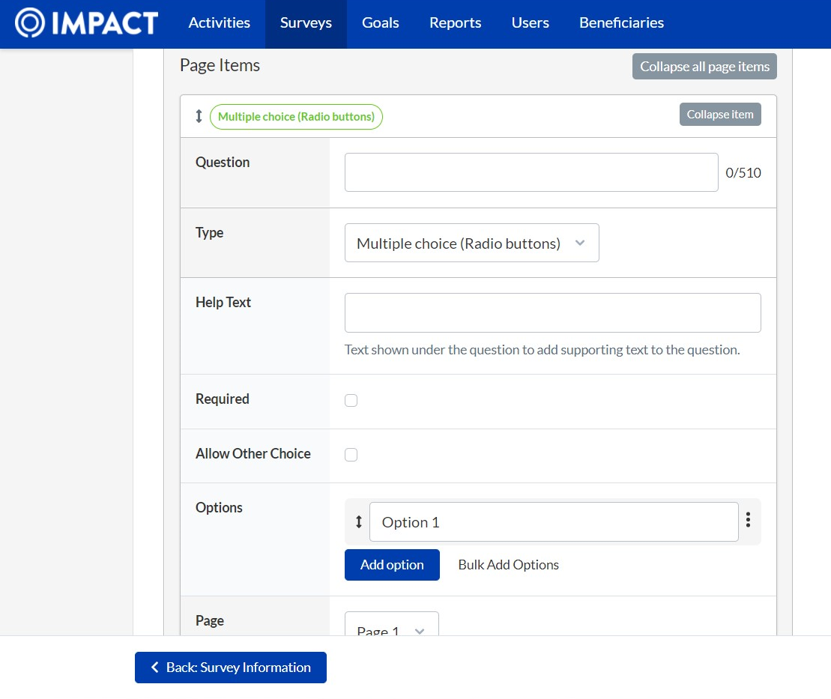
Question – type your question into this box.
Type: The types you are most likely to use are highlighted in green in the table below. Question types highlighted yellow shouldn’t be used or are unlikely to be relevant.
Note: once you’ve created your question you can’t change the question type.
Question Type | Explanatory notes
Text | users fill in their own text – character limit 500
Long Text | as above - character limit 1400
Email | consider data protection requirements and tell people why/how you will use this info
Phone | consider data protection requirements and tell people why/how you will use this info
Heading Label | allows you to create a heading for a set of questions without changing page
Text Label | adds a line of text into the survey
Numeric | give an answer that is a number
Numeric Grid | assign options a numeric value
Date
Time
Duration | allows a response in hours and minutes
Postcode
Single Checkbox | where you need a tick to confirm something
Checkboxes | choose all that apply from a list
Drop down | pick from a drop down menu
Multiple choice (radio buttons) | choose one option out of a list
Multiple choice grid | choose one option
Linear Scale | rate from 0-10
Thermometer EQ5D | Health rating – unlikely to be relevant
Wellbeing Scale | similar to linear scale but with sad to smiley face
Beneficiary | do not use – not available to Community Rail Network members

Help text – add an explanatory note about the question if needed
Required – tick if you require an answer to this question
Allow Other Choice – this will show on relevant questions e.g. checkboxes and allows survey participants to type in their own response if they don’t see it on the list
Options For multiple choice or checkboxes or grids you’ll need to add your options into the boxes. You may find it quicker to type the list directly into the Bulk Add Options box or you can copy and paste a list from another document to save time.
Question Logic This allows you to show questions depending on previous responses. For example, if you ask a yes/no question first you can then add a follow up question for people who respond yes. Create the follow up question as above and click question logic. A drop down menu will allow you to pick the question and response that you’re adding the follow up to.
Changing the order of your questions
You can change the order of questions by clicking on the arrows next to the question and dragging up or down. This is much easier to do if you have collapsed all of the questions first (top right of the question box to collapse individual questions or the collapse all button at the top). You can also add pages and move questions between pages.
Preview your survey
You can Save and preview your survey at any point.
Remember to save your work as you go along. It makes sense to save every couple of questions (bottom right). Impact does not save automatically.
Please note that if you submit responses as part of a preview they will be recorded and you’ll have to ask Admins to delete them. On the preview page you can put in your answers to see how it works but don’t click Submit. Return to the top of the page and go straight to Survey Overview and your responses will not have been recorded.
Link to share the survey
Once you have created your survey you can use the link available on the Survey Overview. Click copy link and use it to email to people, embed on a webpage or send via social media. Impact account users with access to smart phones/tablets could also record responses in real time whilst out and about. You could also use a QR code generator to add the survey link to posters or leaflets.
Viewing and downloading responses
- When you click on the surveys tab on the top menu bar you’ll see the survey you have created and you’ll instantly be able to see how many responses you have had.
- A summary of the responses can be viewed on the Overview page or you can look at the Response Table or you can download the spreadsheet by clicking Download filtered responses CSV.
- Text questions are automatically displayed as word clouds which you can download – this option can be changed by clicking Answers (see all answers in full) or Words (words ranked in order of use)
- You can also create customised views for questions on the Dashboard, e.g. pie charts, by clicking Edit and adding widgets for different questions. Have a play around with this – it does not affect your survey.
- All of the charts you can see are available to download by clicking the 3 horizontal bars on the right hand side and choosing PNG or JPEG
Tips for writing and analysing your survey
- Make the survey as easy as possible to fill in and avoid free text boxes where possible by giving people a list to choose from. You can add an ‘other’ box for additional responses to a checkbox or multiple choice question.
- Question logic – this can help manage survey length as questions are tailored according to individual responses.
- Filter questions - Impact survey responses can be filtered by question so think about how you want to analyse your data and ask questions that you can use as a filter e.g. age, location, local station.
- Analysing responses – The survey overview page gives you options for viewing your data and the filter tab on the left-hand side allows you to choose which responses you see. It is easiest to view and analyse responses while you are in Impact. You can download a spreadsheet with all responses as a backup for future reference.
Closing and deleting your survey
Admins (impact@communityrail.org.uk) can close your survey to prevent further responses if you let is know. Once you’ve finished with your survey, download the responses, let us know that you’ve finished and we can delete the survey completely.
Help and support
Contact impact@communityrail.org.uk and we can arrange a call/video call if necessary. Support is generally offered by the Training and Development team at Community Rail Network.
Please note that we are a part-time team so last-minute requests for help may not be resolved straight away. Allow plenty of time to get your survey ready.
Community Rail Network, March 2022

