ScotRail in The Community
Young Childrens Safety Brief

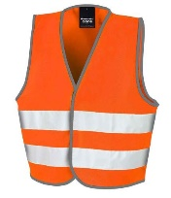 | - Always wear your HI-Visibility Vest.  - When gardening be sure to have your gloves on at all times.
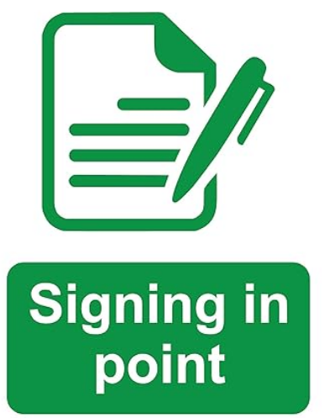 | - When you arrive at the station be sure to sign in with the station staff.  - When you are finished and leaving the station remember to sign out.
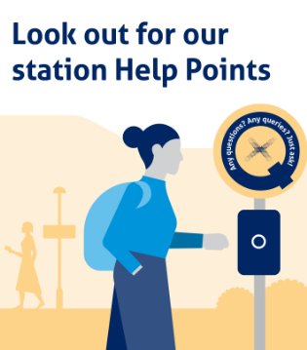 | - If there is no station staff use the help point to sign in.  - When you are finished and leaving the station use the help point to sign out.
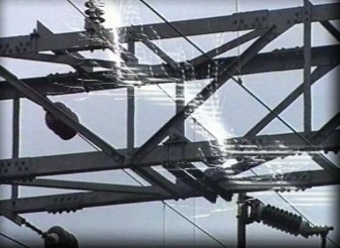 | - Electricity on the railway is LIVE at all times, 25,000 volts  - Electricity can jump, so stay well away from all wires and tracks.
- Stay behind the Yellow line at all times.
- Noone should go on the track.

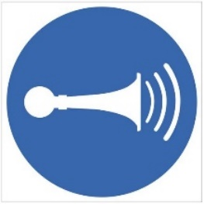 | - If the driver sounds the train horn stop what you are doing and lift your hand above your head, this is so the driver knows you heard the horn and are taking extra care.
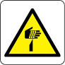 | - If you find anything sharp at the station DO NOT move or touch the item, let your group leader know.  - If you see something that you think someone may have left behind again do not touch this let your group leader know.
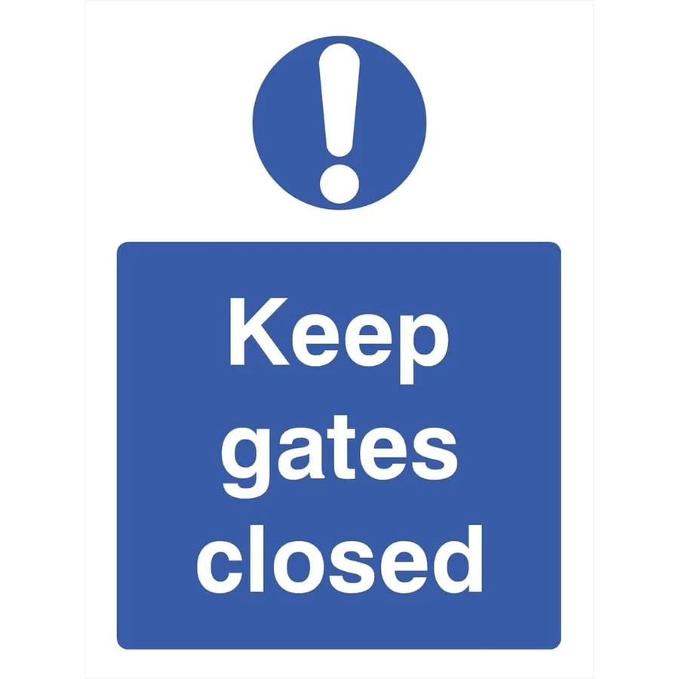 | - Only go into areas that you have been told you are allowed to go into.  - Close all gates and doors behind you.
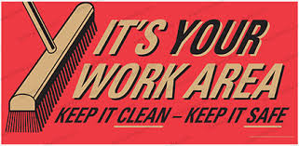 | - You must not leave your tools and equipment lying around.

