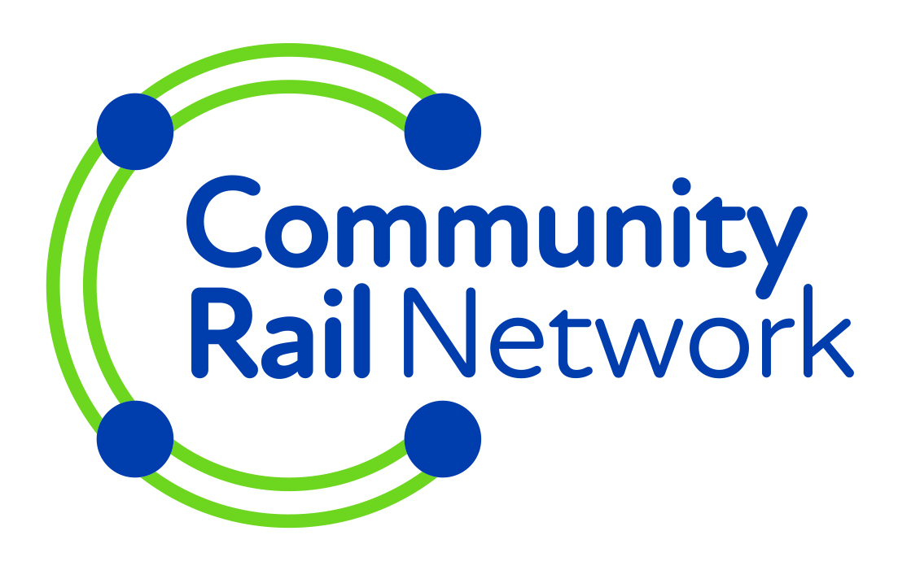

Community Rail Network membership

Community Rail Network is the membership body for community rail partnerships, station adopters, and other groups undertaking community rail activities. Membership gets you our expert advice, free places at our events, access to funding, and more. For further details go to communityrail.org.uk/join-us/.
Which membership category are you applying for? (Follow the link above for details on each category):
Community rail partnership (CRP) ☐
Station adoption /local group ☐
Community station ☐
PART 1 – your details (Sections marked * are essential)
(please ensure you only provide details for people who have given permission for us to contact them)
Group name *
Group postal address
Main contact
name, phone, and/or email *
Secondary contact
name, phone, and/or email *
Line(s) or station(s) covered *
Principal train operator (TOC)
Main TOC contact name, phone, email
Date of your group’s safety briefing from your TOC *
Other contact details you think we should have (e.g. treasurer, secretary, community rail officer):

PART 2 – document(s) you must provide
All groups applying for membership must provide a copy of their project/business plan, or a brief outline of your objectives for the station/line, or a constitution. Check once completed ☐
If you are applying for CRP or community stations membership you also need to supply your official governing documentation or evidence of your status (e.g. constitution, charity number, registered company number, etc). Check once completed ☐
If you are applying for Community Rail Partnership member you will be expected to have discussed and developed your plans with a member of the Community Rail Network Support and Development team before applying for membership. CRP membership applications must also be approved by Community Rail Network’s board, which meets quarterly.
PART 3 – agreeing to our code, using our guidance
We ask ALL members and their volunteers to take time to read our guide Station Adoption: A Guide for the Local Community (available at https://communityrail.org.uk/wp-content/uploads/2023/06/Station-adoption-a-guide-for-the-local-community.pdf) and to abide by the Community Rail Network Station Adoption Code of Conduct and Women in Community Rail Code of Conduct (WiCR, see wicr.org.uk), as shown below, regardless of their membership category.
Community Rail Network’s station adoption code of conduct:
- appropriate permission must be obtained from the train operator (and/or Network Rail where relevant) before undertaking any work at a station, and you must only work in areas where you have been given permission to do so;
- comply with all terms and conditions for station groups specified by your train operator (and/or Network Rail where relevant), including:
- signing in when arriving at the station;
- wearing specified high-vis gear and using suitable equipment;
- never interfering with railway equipment,
- report any incidents using the specified procedures;
- ensure no volunteers/group members ever work under the influence of drugs or alcohol;
- ensure no volunteers/group members go on the track or lineside under any circumstances.
- never put yourself or anyone else in a situation that poses personal risk;
- ensure that no member of the group acts in a manner that may bring your group or the community rail movement into disrepute;
- any issues regarding the train operator or Network Rail must be raised directly and handled internally within the rail industry;
- ensure your group is open to everyone regardless of race, colour, nationality, ethnic or national origin, gender identity, sexual orientation, or religious belief, and operates in line with the Equal Opportunities Act;
- all group members and volunteers should adhere to the inclusive, positive behaviours set out in the Women in Community Rail code of conduct (see below);
- if mentioning Community Rail Network or using its logo in any publicity materials or in a press release please ensure we see a copy beforehand (email sarahc@communityrail.org.uk);
- use and draw on the guidelines in our publication Station adoption: a guide for the local community
Women in Community Rail (WiCR) code of conduct:
- Promote positive relationships to deliver positive outcomes and discussions
- Champion diversity and inclusion, aiming to ensure that community rail is welcoming, engaging and respectful for everyone
- Value others by listening and not making assumptions
- Challenge bullying, harassment, intimidation and report all negative behaviour
- Never act in a manner that could bring community rail into disrepute
Please check this box to indicate that you agree to these codes: ☐
PART 4 - payment
Please select a method of payment:
☐ Cheque, made payable to Community Rail Network
☐ Bank transfer – please contact us for details
☐ Please send me an invoice
☐ I am in one of the free categories outlined below (please check with Community Rail Network if unsure).
Membership fees
Community rail partnership (funded group) | £150+VAT (£180)
Community rail partnership (unfunded group) | £75+VAT (£90)
Community Station (funded group) | £80+VAT (£96)
Community Station (unfunded group) | £40+VAT (£48)
Station adoption / local group | £25+VAT (£30)
South Western Railway or Transport for Greater Manchester area  (station adoption groups or community station members only) | Free

Your name: | Date:

Please return the completed form to membership@Communityrail.org.uk, or if posting, send to Community Rail Network, The Old Water Tower, Huddersfield Railway Station, St Georges Square, Huddersfield HD1 1JF.
Data privacy
In order to operate effectively Community Rail Network needs to collect, maintain and use certain personal information about current, past and prospective members. All such personal information, whether held on computer, paper or other media, will be obtained, handled, processed, stored & transported lawfully and correctly, in accordance with the principles and safeguards contained in the Data Protection Act 1998, GDPR Regulations (Article 5) and Data Protection Act 2018. We will use your personal data solely for your involvement in our activities and communicating with you about your membership. We will not share it with any third party. Our privacy policy can be found at communityrail.org.uk/privacy-policy/.

