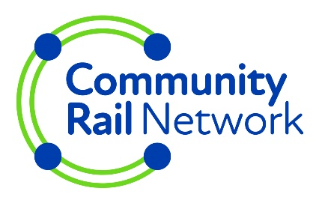
Application to Community Rail Network training bursary scheme

Please read the bursary guidelines before making an application. You must be from a member organisation.
If you are successful the bursary fund will reimburse your organisation/group for the costs of the course, as agreed, after completion.

Your contact details:
Name: Click or tap here to enter text.
Organisation: Click or tap here to enter text.
Address: Click or tap here to enter text.
Postcode: Click or tap here to enter text.
Phone: Click or tap here to enter text.
Email: Click or tap here to enter text.

Tell us about the course/conference you want to attend:
Course or Conference Title: Click or tap here to enter text.
Course or Conference Trainer/Organiser: Click or tap here to enter text.
Contact Details for Course or Conference Organiser: Click or tap here to enter text.
Course Date: Click or tap here to enter text.
Total Cost of the course: Click or tap here to enter text.
Amount requested from the training bursary scheme: Click or tap here to enter text.
Please insert a link to the online publicity for the course: Click or tap here to enter text.
If a link is not available please send us a copy of the course publicity either by post or a scanned copy via email

NB: Bursaries are only available for externally provided courses/conferences etc. We do not provide bursaries for places on internal courses or those run by other CRN members.
Why do you want to attend this course/event?
Click or tap here to enter text.
How will attending this course benefit your community rail organisation or group?
Click or tap here to enter text.

Please note that, once the bursary is agreed, your organisation/group will be expected to pay for the course up front and claim re-imbursement from the bursary fund using the claim form we will send to you.
I have read and agree to the conditions set out in the current Bursary Guidelines (please tick)

Email this form to training@communityrail.org.uk

Contact Details
Community Rail Network
The Old Water Tower
Huddersfield Station
HD1 1JF

Data Privacy: Personal information supplied on this form will be used to communicate with you specifically about your bursary application, to allow us to assess the application and to monitor and evaluate the overall scheme. It will not be used for any other purpose. This information will be processed, stored & transported lawfully and correctly, in accordance with the principles and safeguards contained in the Data Protection Act 1998 and GDPR Regulations (Article 5). Your personal information may be shared with third parties, such as the Department for Transport, where it is deemed necessary, to assess the application and report on the bursary scheme’s activity. Community Rail Network’s Data Privacy Policy can be found on its website.

End

