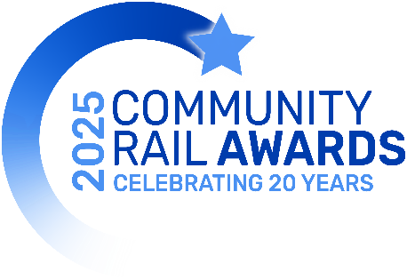

Booking Form

The 2025 gala dinner & ceremony is being held at the Iconic Civic Centre in Newcastle, on Thursday 13 March.
The drinks reception will be from 17:00, followed by dinner, and the awards ceremony in the main hall.
There will be plenty of opportunity for networking and catching up with friends and colleagues and time to enjoy the entertainment.
Dress code is smart/cocktail wear (not black tie). Joining instructions will be sent out two weeks before the event.

Bookings to be received by 14 February, but early booking is encouraged to assist with seating and table allocations. CRP and station adoption shortlistees - please check with your primary TOC before making any separate bookings. This is to avoid unnecessary cancellation admin and potential costs to you.

COST: Individuals, community/voluntary groups: £60+VAT (£72) pp or £500+VAT (£600) table of 10.
Commercial and public-sector organisations: £120+VAT (£144) pp or £1000+VAT (£1200) table for 10.

BOOKING DETAILS

I would like to book places or table/s

NB: Wine is not included and can be ordered in advance directly from the venue. A wine list and ordering details will be emailed/sent to you a few weeks before the event.
Payment Method – Please select one option:

- Please invoice me for £
Please supply Purchase Order number (if applicable) here:

- I do not need an invoice and will make a payment by BACs transfer to: Community Rail Network Ltd
Sort Code: 30-94-43 Account No: 04129427 Reference: ‘CRA25 Gala Dinner’ + name/group/organisation
Contact Name:

Position & Organisation:

Address:

Invoice address: (if different)

Phone:
Email:

GUESTS: On the guest list template, please list the name of each individual guest and any special requirements (dietary, disability etc). If these details are not known at this stage, please email them a.s.a.p, but no later than 14th February.
Signature:

Cancellations – please note that in the event of cancellation at any time up to one week before the dinner date, an administration charge may be payable at our discretion and that a cancellation fee of half the value of the booking will be levied thereafter. I recognise that completion of this form implies acceptance of its conditions.

Data Privacy: All personal information supplied on this form and guest list template will only be used to communicate specifically about this event and your booking. This information will be processed, stored & transported lawfully and correctly, in accordance with the principles and safeguards contained in the Data Protection Act 1998 and GDPR Regulations (Article 5). We will not share it with any third party. Our Data Privacy Policy can be found on our website.

Any queries please ring Hazel: 07939 958752 or Hannah: 07734 113989.
Email completed forms by 14 February to: events@communityrail.org.uk Thank you!
Guest list(s) for [insert organisation name]

Please complete the following table/s, specifying each individual guest name and any special requirements (dietary, disability etc.), and email to events@communityrail.org.uk by 14 February

Any queries please ring Hazel: 07939 958752 or Hannah: 07734 113989
First Name | Surname | Organisation | Special Dietary  Or Other Requirements

First Name | Surname | Organisation | Special Dietary  Or Other Requirements

First Name | Surname | Organisation | Special Dietary  Or Other Requirements

