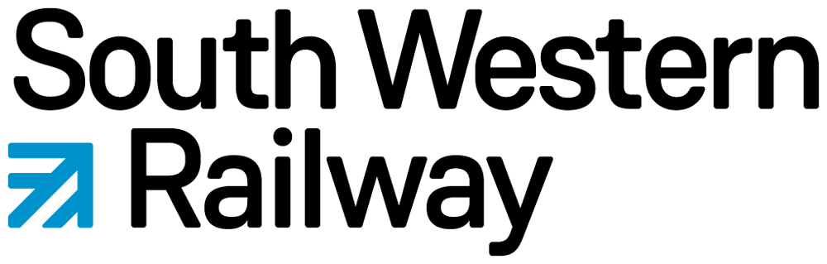

APPLICATION TO SOUTH WESTERN RAILWAY’S STATION ADOPTION FUND (SAF)
Administered by Community Rail Network
(Please read the Application Guidelines first)

Name of station adoption / friends’ group (one station adoption group per form):

Name of contact person:
.
Address of contact person:

Phone of contact person: Email of contact person:

Project name:

Name of organisation where grant will be paid to (if different from name of station adoption group):

Project Details: (Filling in by pen? Continue on a separate sheet for any section, if necessary)

If your project includes activities conducted on SWR or Network Rail property/land, we must see written permission for those specific activities.

Have you provided evidence of SWR permission or expense approval? Yes [ ] Not Applicable [ ]
Have you provided evidence of Network Rail permission? Yes [ ] Not Applicable [ ]

How will this project benefit the local community?

How are the local community be involved?

Total project cost | Amount being requested from the SWR SAF fund | % of total project cost
£ | £

Itemised list of what the money requested from the SWR Station Adoption Fund will be used for:
The listed items should total the amount you are requesting from us, or total cost of the project. For any item £200 or more, we request evidence of cost, such as supplier quotes and/or webpage links showing online prices.

Budget item | Cost | How you are providing evidence of cost (if £200 or over)
Total:

As part of good financial governance, we request you keep all receipts and project records for six years. We financially audit a proportion of grant-funded projects annually, and members undergoing financial audit checks will be required to submit evidence (e.g. receipts and invoices) to support their submitted budget. Any budgetary discrepancies will be investigated and may result in a re-payment of funds. This financial audit process is currently subject to DfT review; any changes affecting your application will be communicated to you. Please check here to confirm you agree to this requirement: [ ]

Your name:

Position in organisation:

Date:

SWR Station Adoption Fund: Guidelines for applicants
SWR funding to Community Rail Network enables our member organisations in the SWR region to undertake small projects that aim to benefit the station they have adopted.

The following criteria apply:
- The fund can only provide grants to Community Rail Network members in the SWR area that have Station Adoption or Community Station membership, unless Community Rail Network deem special circumstances apply.
- Applications can only be accepted if made on Form 1a-SWR.
- The fund can support projects up to a maximum contribution of £250 for Station Adoption Group members or £1,000 for Community Station members.
- Higher award amounts may be considered in special circumstances, but these must be discussed in advance and agreed in writing with the SWR Community Rail Manager and Community Rail Network Member Support Officer.
- Station adoption groups are strongly encouraged to plan their activities in advance; therefore, the fund does not support projects that are already underway or have been completed,
- However, we are aware that there are some small gardening expenses, incurred by station adoption groups that can only be claimed in arrears. Claims for these must be agreed between SWR’s Community Rail Manager and the Community Rail Network Member Support Officer with written evidence provided with your application. Claims must be submitted as a single application per station and must be accompanied by clear, legible, dated receipts and must be submitted within two months of the expense being incurred. Reimbursement can only be made for items relevant to station adoption activities and the panel’s decision on payment against receipts for items is final.
- We are not able to reimburse private car mileage or fuel costs through the Station Adoption Fund.
- There is no requirement for match funding as part of an application to this fund.
- Applications will be considered at any time and will be determined by agreement of a panel (with deputies in their absence) consisting of: SWR, Community Rail Manager (or another SWR representative), Community Rail Network, Member Support Officer (or other Support & Development officer) and one external independent panel member.
- SWR and Community Rail Network support should be clearly displayed acknowledged in press releases and other publicity and, where appropriate, typically through use of the ‘SWR’ logo and ‘Community Rail Network – Funded’ logo which are made available and included in the email notifying an applicant of approved funding.
- Whilst more than one application per station is acceptable, in considering bids there will be a presumption in favour of applicants who have not made a successful application earlier in the same year. However, this is subject to available funds, and a good application from a previously successful applicant would not necessarily be rejected.
- Grants will remain claimable for up to three months following the award date. Grants remaining unclaimed after this date will be cancelled and the funds made available to other applicants.
- We reserve the right to conduct a project audit. Failure to respond to our request to fill in our post-funding evaluation form could result in your group being disqualified from future bids.
- The level of grant awarded is at the discretion of SWR and Community Rail Network who reserve the right to part-fund or refuse a bid as they see fit.
- This form must be returned either by email to grants@communityrail.org.uk or by mail to the office.
- We will acknowledge receipt and give an indication as to when we expect the application to be considered by. This will normally be within 14 days.

What sort of projects are eligible?
The fund……
- exists to assist members in developing a wide range of practical schemes which make a real difference to their stations, communities and rail services
- may include small items (e.g., gardening supplies, notice boards) or revenue funding (e.g. rail-link bus, special events, etc.)
- should not generally be used to support projects that more properly should be provided by the rail industry or other agencies
We would expect to see……
- clear evidence of community benefit (including local residents and/or visitors)
- some evidence of community involvement, where appropriate
- that the project has identified the need for its existence.

Data Privacy: Personal information supplied on this form will be used to communicate with you specifically about your grant application, and to allow us to evaluate and assess the progress of the project for which you are applying for funds. It will not be used for any other purpose. This information will be processed, stored & transported lawfully and correctly, in accordance with the principles and safeguards contained in the Data Protection Act 1998, GDPR Regulations (Article 5) and Data Protection Act 2018. Your personal information may be shared with third parties, such as the Department for Transport, Network Rail, train operating companies and devolved government, where it is deemed necessary to assess the application. Community Rail Network’s Data Privacy Policy can be found on its website.

