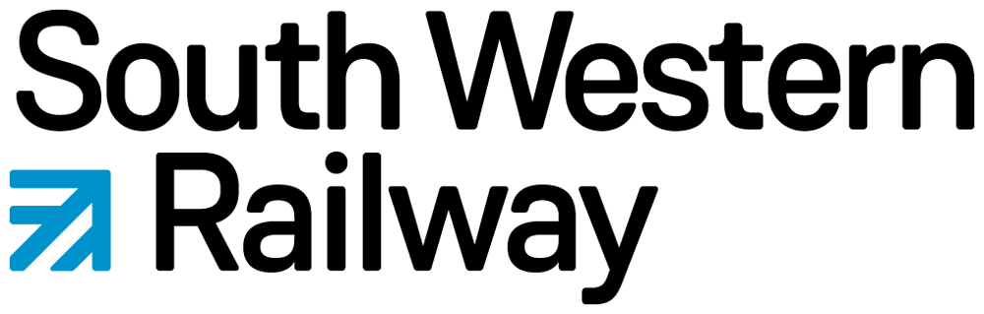

Station Adoption Fund Expenses Claim Form
Administered by Community Rail Network (CRN)

Organisation/Group Name: | Claim Month(s): | Date: 01/04/2026

Receipt Date | Full description of receipt(s) including name of the retailer and purchases i.e. New Bank Garden Centre – plants, compost, fertiliser |  |  | Amount  £ p | CRN use only
 |  |  | Total Claim

Claimant’s Certification:  I certify that I have read and understood and comply with the SWR Station adoption expense fund applicant guidelines and submission process. Please see the guidelines below. |  | Tick:
SWR Permission:  I confirm that our group has permission from SWR for this expense to be incurred. |  | Tick:
Claimant’s Name:

Organisation/Group Bank Account  Name of the account:  Sort Code:  Account Number: | NB: Personal bank account details will be declined

Authorisation:  (CRN use only) | Community Rail Network | South Western Railway
Print Name:

Position:

SWR Station Adoption Expense Fund: Applicant Guidelines
The South Western Railways (SWR) Station Adoption Expense Fund, overseen by Community Rail Network (CRN), provides financial support to station adoption groups within the South Western Railway (SWR) region. This fund helps cover costs associated with ‘small’ gardening & maintenance related expenses which go towards enhancing adopted stations, ensuring they remain welcoming and well-maintained for the community.

Eligibility Criteria
Station adoption groups can submit expense claims in arrears, for consideration, providing they meet the following criteria:
- They are an approved Station adoption or Community station member of SWR and CRN.
- Claims can only be made for small items relevant to station adoption activities, station gardening or minor works (e.g. art or displays in a station foyer or waiting room) which enhance the station for the benefit of the community.
- Expense claims can only be submitted as a single application per station adopter group.
- Each claim must include clear, legible and dated receipts, showing VAT numbers where applicable.
- Private car mileage or fuel costs are not eligible for reimbursement.
- Claims must be submitted within two months of the expense as shown on the receipt being incurred.
- Payments can only be made to an organisation’s bank account (not personal accounts).
- Please be aware that pre-planned projects and activities, such as art displays and engagement events, should be funded through the Small Grants fund or SWR Station Adoption Fund.

Claim Limits
- Maximum claim per submission: £250 (covering up to a two-month period). If larger amounts of funding are required, then these should be made in advance as a pre-planned project funding application to this fund.
- More than one expense claim per station group may be permitted within a given financial year: 1 April – 31 March. Please seek confirmation from the Community Rail Network Member Support Officer at j.jones@communityrail.org.uk

Some Examples of Eligible Expenses
- Plants, soil, pots and compost for station gardens/tubs.
- Tools and equipment related to station adoption activities (excluding personal tools).
- Refreshments, volunteer work days.
- Cleaning materials.
- Small artwork repairs.
In order to avoid disappointment, please check that items are eligible for reimbursement before making the purchase.

Submission Process
- Complete the SWR expense claim form (available via Community Rail Network website).
- Ensure the full bank account details are completed and are correct on the form for the organisation where the grant is to be paid.
- Having read and followed the Eligibility Criteria (shown above), attach to the claim all relevant receipts, ensuring these are clear, legible and dated, showing VAT numbers where applicable.
- Email the completed claim form and receipts to the Community Rail Network Member support officer (j.jones@communityrail.org.uk).
- Claims and receipts will be checked and reviewed to confirm eligibility.
- If additional information is required or the claim does meet the criteria, the Member support officer will contact the group for resubmission or discussion.
- The Community Rail Network Member support officer also manages communication with the group regarding any issues or delays.
- If the claim is validated and also approved by the SWR Community Rail Manager, the Member support officer will send the group an approval notification.
- Following approval, the Member support officer will email the claim, receipts, and any additional details to the Senior admin assistant at grants@communityrail.org.uk to add to the SWR spreadsheet (referencing expense claim), who will then forward on to finance@communityrail.org.uk for payment of the expense.

Payment terms
Within 30 days from receipt (into finance@communityrail.org.uk) of a signed approved to pay expenses notification form. (subject to annual leave and sickness leave)
- Reimbursement is only for items directly related to station adoption as described in the Eligibility Criteria above.
- Decisions made by Community Rail Network and SWR regarding claims are final.

We will endeavour to complete the above process within a 2-month period from initial submission of the expense fund application (subject to annual leave and sickness leave).

Contact Information
For queries or support, please contact, Community Rail Network Member Support Officer, Jenni Jones: j.jones@communityrail.org.uk / 07398 984 784.

/Ends

Any receipts submitted outside of this period will be automatically rejected.

