‘Alt text’ image descriptions for Community Rail Week social media graphics
Copy and past the text below into the ‘alt text’ field when uploading the graphic to your social media post.
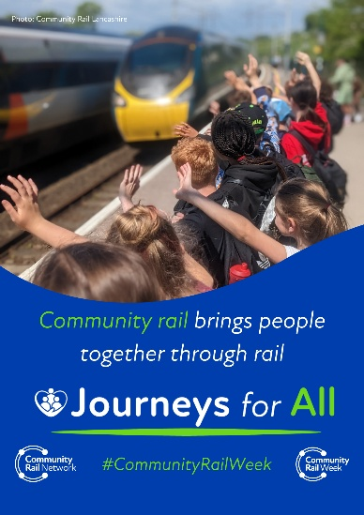
Photo at the top (courtesy of Community Rail Lancashire) shows a busy platform full of secondary school children waving at an Avanti West Coast train pulling into a station. The white and bright green text below, on a deep blue background, reads: “Community rail brings people together through rail. Journeys for All. #CommunityRailWeek.” Two copies of the white Community Rail Network logo are at the bottom of the image.

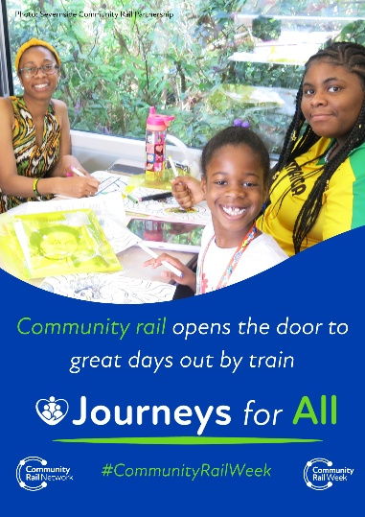
Photo at the top (courtesy of Severnside Community Rail Partnership) shows two women and a young girl on board one of Great Western Railway's special event trains to Notting Hill Carnival, taking part in colouring and other activities on their table. The white and bright green text below, on a deep blue background, reads: “Community rail opens the door to great days out by train. Journeys for All. #CommunityRailWeek.” Two copies of the white Community Rail Network logo are at the bottom of the image.

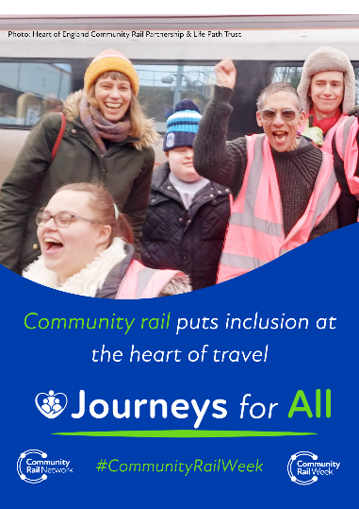
Photo at the top (courtesy of Heart of England Community Rail Partnership) shows a group of participants from the Life Path Trust, a charity that supports people with learning disabilities, having just alighted a train at Coventry Station. They are smiling and excitedly waving their hands in the air. The white and bright green text below, on a deep blue background, reads: “Community rail puts inclusion at the heart of travel. Journeys for All. #CommunityRailWeek.” Two copies of the white Community Rail Network logo are at the bottom of the image.

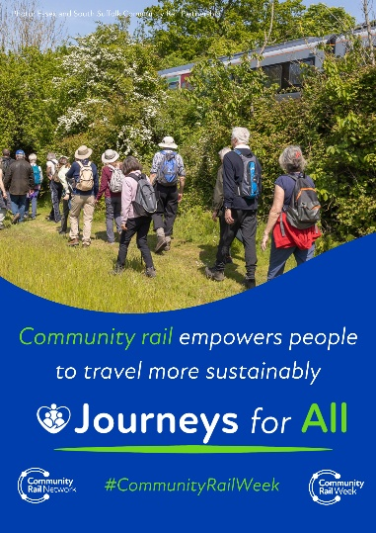
Photo at the top (courtesy of East Suffolk Lines Community Rail Partnership) shows a group of people on a ramble on a sunny day. They are wearing hats, backpacks and walking shoes and walking through a field; a train whizzes past on the track above. The white and bright green text below, on a deep blue background, reads: “Community rail empowers people to travel more sustainably. Journeys for All. #CommunityRailWeek.” Two copies of the white Community Rail Network logo are at the bottom of the image.

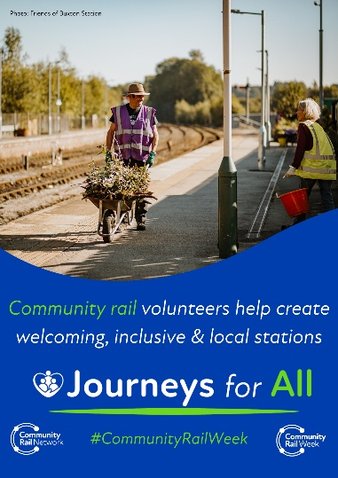
Photo at the top (courtesy of the Friends of Buxton Station) shows two volunteers wearing hi-vis jackets doing gardening work on the platform at Buxton Station. The man is pushing a wheelbarrow of foliage down the platform, and the woman holds a bucket. The white and bright green text below, on a deep blue background, reads: “Community rail volunteers help create welcoming, inclusive and local stations. Journeys for All. #CommunityRailWeek.” Two copies of the white Community Rail Network logo are at the bottom of the image.

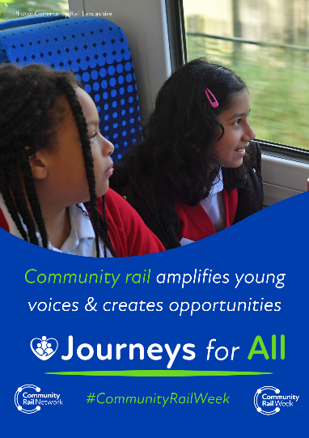
Photo at the top (courtesy of Community Rail Lancashire) shows two female primary school students on board a Northern train, looking out the window. The white and bright green text below, on a deep blue background, reads: “Community rail amplifies young voices and creates opportunities. Journeys for All. #CommunityRailWeek.” Two copies of the white Community Rail Network logo are at the bottom of the image.

